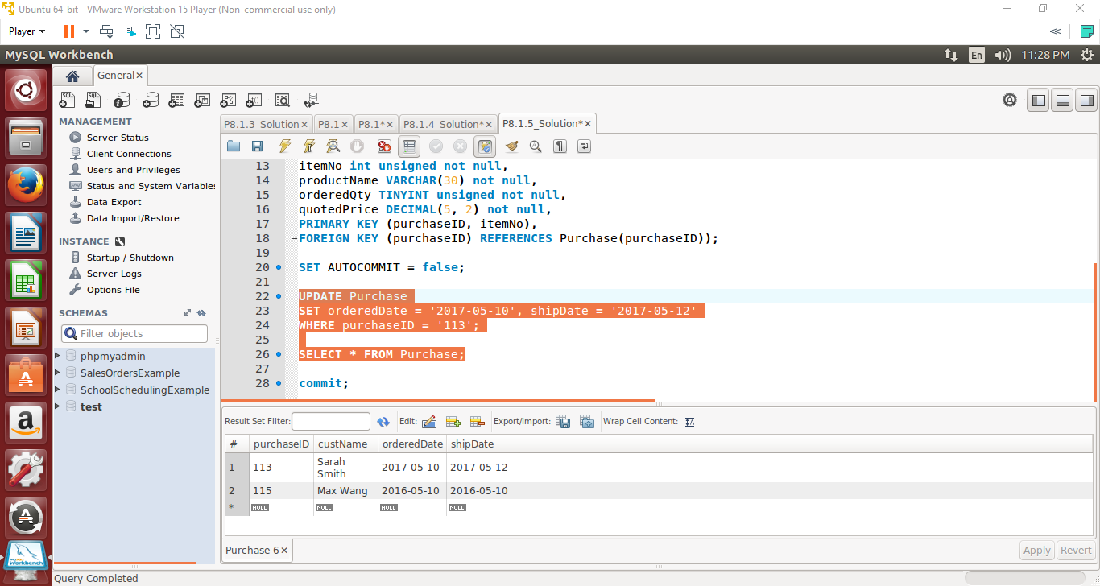

The UPDATE command allowed us to modify an existing table. The SET command was used to change the orderedDate and shipDate. The WHERE statement was to restrict the modification to just the tuple containing the purchaseID of 113.